Activity: UML Final Project – Title & Design Proposal
Project Title
Design and Development of a UML-Based Parking Latte Coffee Ordering System

Problem Statement
Traditional verbal ordering in a busy café environment frequently introduces human error, leading to incorrect drink preparations, wasted ingredients, and extended customer wait times. Furthermore, manual tracking of complex beverage customizations (such as milk alternatives and sweetness levels) slows down barista workflows behind the counter. Without an integrated backend system, store management also struggles to monitor real-time ingredient inventory and track sales data, resulting in unexpected supply shortages and operational inefficiencies.

Project Objectives
- Modernize Order Intake: Provide a digital platform for customers to seamlessly browse menus and apply precise drink customizations, minimizing communication errors.
- Optimize Barista Workflow: Establish a real-time order fulfillment queue ("Pending," "Preparing," "Completed") to reduce customer wait times and improve counter efficiency.
- Automate Inventory Management: Track ingredient usage automatically based on orders placed and trigger immediate alerts when stock levels run low.
- Secure Financial Transactions: Integrate reliable payment processing options, supporting both digital payment gateways and traditional cash-on-counter methods.
- Enhance Administrative Control: Enable managers to dynamically update menu items, prices, and view performance reports for data-driven decision-making.

Target Users
- Customer: The primary external user who browses the digital menu, customizes beverage choices, places orders, and completes transactions.
- Barista / Staff: The operational backend user who manages the preparation queue, views specific drink modifications, and updates live fulfillment statuses.
- Store Manager / Admin: The administrative user responsible for menu maintenance, inventory oversight, and analyzing sales/performance metrics.

System Scope
Inclusions (What is Included):
- Customer-facing self-service digital menu with real-time customization options (e.g., sweetness levels, espresso shots, milk substitutes).
- Secure payment gateway integration alongside cash-on-counter transaction recording.
- Barista dashboard featuring a live-updating order processing queue.
- Automated inventory system that deducts ingredients per order and sends low-stock warnings to management.
- Admin panel for real-time menu editing (adding/removing items, adjusting prices) and generating basic sales reports.
Exclusions (What is Excluded):
- Delivery fleet logistics or integration with third-party delivery services (e.g., GrabFood, Foodpanda); the system is strictly for in-store or pickup orders.
- Advanced accounting software integration or employee payroll/shift scheduling management.
- Customer loyalty reward point redemption systems (reserved for future updates).

UML Use Case Diagram
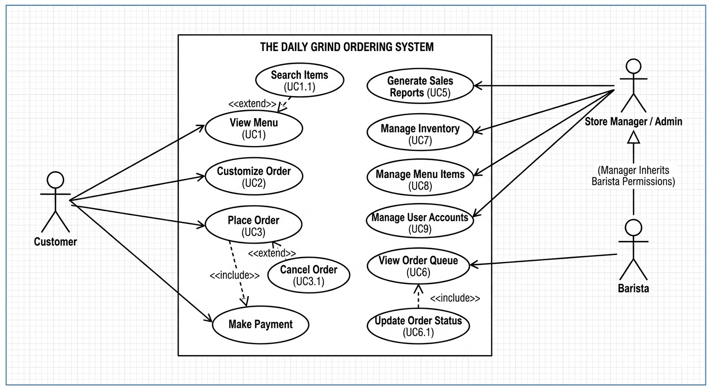
Parking Latte Coffee Ordering System

